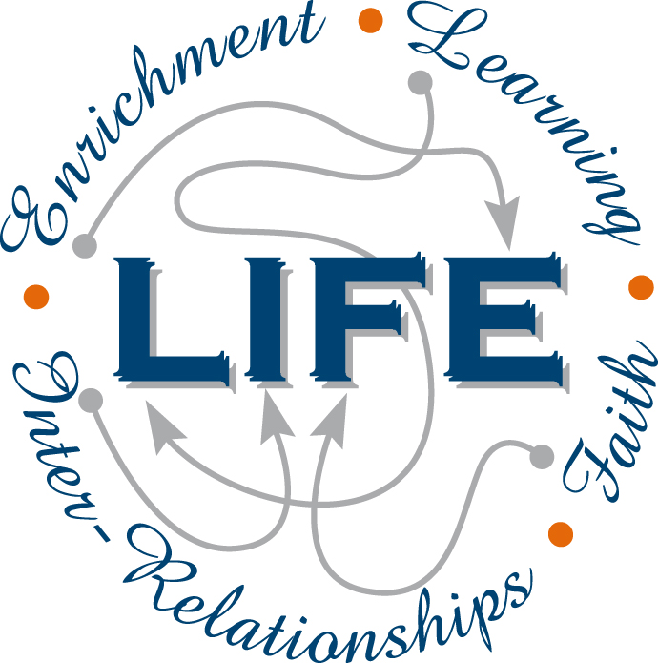
Holy Cross College

Semester 1 Examination 2018

Question/Answer Booklet

Please place your student identification label in this box
Year 10 Science

Student Name
Student’s Teacher

Time allowed for this paper

Reading time before commencing work: 10 minutes
Working time for paper: 110 minutes

Materials required/recommended for this paper

To be provided by the supervisor

This Question/Answer Booklet
Data Sheet

To be provided by the candidate

Standard items: pens, pencils, eraser, correction fluid, ruler, highlighters.
Special items: non-programmable calculators satisfying the conditions set by the School Curriculum and Standards Authority for this course.

Important note to candidates

No other items may be taken into the examination room. It is your responsibility to ensure that you do not have any unauthorised notes or other items of a non-personal nature in the examination room. If you have any unauthorised material with you, hand it to the supervisor before reading any further.

Structure of this paper

Section | Number of questions available | Number of questions to be answered | Suggested working time  (minutes) | Marks available | Percentage of exam
Section One:  Multiple Choice | 55 | 55 | 40 | 55 | 35
Section Two:  Short Answer | 17 | 17 | 55 | 87 | 55
Section Three:  Comprehension | 9 | 9 | 15 | 17 | 10
 |  |  |  | 163 | 100

Instructions to candidates

1. The rules for the conduct of examinations at Holy Cross College are detailed in the College
Examination Policy. Sitting this examination implies that you agree to abide by these rules.

2. Write your answers in this Question/Answer Booklet.

3. Working or reasoning should be clearly shown when calculating or estimating answers.

4. You must be careful to confine your responses to the specific questions asked and to follow
any instructions that are specific to a particular question.

5. Spare pages are included at the end of this booklet. They can be used for planning your
responses and/or as additional space if required to continue an answer.

• Planning: If you use the spare pages for planning, indicate this clearly at the top of the
page.
• Continuing an answer: If you need to use the space to continue an answer, indicate in
the original answer space where the answer is continued, i.e. give the page number.
Fill in the number of the question(s) that you are continuing to answer at the top of the
page.

SECTION 1 MULTIPLE CHOICE (56 marks)

Choose the best answer for each question in the Multiple Choice Question booklet.

Mark your selection with a cross.

1 | (a) | (b) | (c) | (d) |  | 31 | (a) | (b) | (c) | (d)
2 | (a) | (b) | (c) | (d) |  | 32 | (a) | (b) | (c) | (d)
3 | (a) | (b) | (c) | (d) |  | 33 | (a) | (b) | (c) | (d)
4 | (a) | (b) | (c) | (d) |  | 34 | (a) | (b) | (c) | (d)
5 | (a) | (b) | (c) | (d) |  | 35 | (a) | (b) | (c) | (d)
6 | (a) | (b) | (c) | (d) |  | 36 | (a) | (b) | (c) | (d)
7 | (a) | (b) | (c) | (d) |  | 37 | (a) | (b) | (c) | (d)
8 | (a) | (b) | (c) | (d) |  | 38 | (a) | (b) | (c) | (d)
9 | (a) | (b) | (c) | (d) |  | 39 | (a) | (b) | (c) | (d)
10 | (a) | (b) | (c) | (d) |  | 40 | (a) | (b) | (c) | (d)
11 | (a) | (b) | (c) | (d) |  | 41 | (a) | (b) | (c) | (d)
12 | (a) | (b) | (c) | (d) |  | 42 | (a) | (b) | (c) | (d)
13 | (a) | (b) | (c) | (d) |  | 43 | (a) | (b) | (c) | (d)
14 | (a) | (b) | (c) | (d) |  | 44 | (a) | (b) | (c) | (d)
15 | (a) | (b) | (c) | (d) |  | 45 | (a) | (b) | (c) | (d)
16 | (a) | (b) | (c) | (d) |  | 46 | (a) | (b) | (c) | (d)
17 | (a) | (b) | (c) | (d) |  | 47 | (a) | (b) | (c) | (d)
18 | (a) | (b) | (c) | (d) |  | 48 | (a) | (b) | (c) | (d)
19 | (a) | (b) | (c) | (d) |  | 49 | (a) | (b) | (c) | (d)
20 | (a) | (b) | (c) | (d) |  | 50 | (a) | (b) | (c) | (d)
21 | (a) | (b) | (c) | (d) |  | 51 | (a) | (b) | (c) | (d)
22 | (a) | (b) | (c) | (d) |  | 52 | (a) | (b) | (c) | (d)
23 | (a) | (b) | (c) | (d) |  | 53 | (a) | (b) | (c) | (d)
24 | (a) | (b) | (c) | (d) |  | 54 | (a) | (b) | (c) | (d)
25 | (a) | (b) | (c) | (d) |  | 55 | (a) | (b) | (c) | (d)
26 | (a) | (b) | (c) | (d)
27 | (a) | (b) | (c) | (d)
28 | (a) | (b) | (c) | (d)
29 | (a) | (b) | (c) | (d)
30 | (a) | (b) | (c) | (d)

SECTION 2 SHORT ANSWER (87 marks)

Attempt all questions. Write your answers in the spaces provided.

1. Classify the following elements as alkali metals, transition metals, metalloid (semi-metals),
halogens or noble (inert) gases. Use the periodic table on the data sheet provided.

K Ge He Cu Fr Cl Ag Ar
(4 marks)

Alkali Metal | Transition Metal | Metalloid  (Semi-Metal) | Halogen | Noble (Inert) Gas

2. Complete the following table showing the constituent particles of each element.
(4 marks)
Element | Protons | Neutrons | Electrons

3. An aluminium atom () has the ability to form the Al³⁺ ion. It can then form ionic
compounds with other ions such as Cl¹⁻.

(a) Draw a diagram to show the electron configuration in the aluminium atom.
(2 marks)

(b) Explain what happens in order for the aluminium atom to become the aluminium ion
Al³⁺. (2 marks)

(c) Why is the Al³⁺ ion so stable? (2 marks)

(d) Explain how the "ionic bond" arises between the Al³⁺ ion and the Cl¹⁻ ion.
(2 marks)

4. Write the chemical formula for each of the following compounds.
(7 marks)
NAME | FORMULA
potassium nitrate
magnesium phosphate
aluminium sulphate
phosphorus tribromide
iron (III) iodide
barium acetate
disulphur tetraiodide

5. Balance the following equations. (6 marks)

(a) Al₂(CO₃)₃ + HCl AlCl₃ + H₂O + CO₂

(b) C₃H₈ + O₂ CO₂ + H₂O

(c) NaOH + Fe(NO₃)₂ Fe(OH)₂ + NaNO₃

6. Write fully balanced equations for the following. (4 marks)

(a) calcium carbonate + phosphoric acid (H₃PO₄) calcium phosphate + water +
carbon dioxide

(b) hexane (C₆H₁₄) + oxygen carbon dioxide + water

7. Draw the electron configurations for the following. Include the particles in the nucleus. (4 marks)

(a) (b)

8. A student makes two cups of tea and adds some sugar to each, allowing it to dissolve for 30 seconds. One cup has a teaspoon of sugar grains added while the other has a sugar cube added. (Assume the teaspoon of sugar and the sugar cube contain the same amount of sugar.)

(a) Identify which cup of tea would be sweeter after 30 seconds. Justify your answer. (2 marks)

(b) Describe two more things you could do to increase the rate the sugar dissolves in the tea. (2 marks)

9. How long will it take to complete a trip by car from Perth to Kalgoorlie, a distance of 595 km, travelling at an average speed of 85 km/h? (3 marks)

10. Vincent dropped a stone down a well and saw it hit the bottom 3.5 s later. Calculate the
velocity of the stone at impact, given the acceleration due to gravity is 9.80 m/s² and the stone starts from rest. (3 marks)

11. Sean steps on the brake pedal of his car for 2.5 s. This applies a regarding force of 2100 N to
slow his 750 kg car, which is travelling in an easterly direction. Calculate his car's
deceleration. (3 marks)

12. Consider the forces acting on the car in the diagram below.

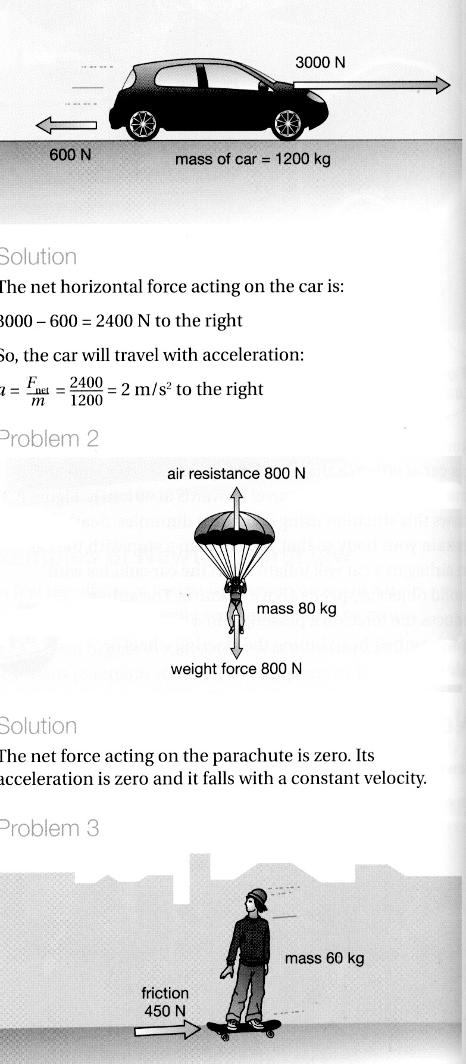

(a) Calculate the nett force acting on the body. (2 marks)

(b) Calculate the acceleration of the body. (3 marks)

13. Max has a mass of 57 kg on Earth. He is lucky enough to be selected for a junior astronaut
programme and journeys to the International Space Station (ISS) for a 3-month stay.

(a) Calculate Max's weight on Earth. (3 marks)

(b) Max "floats” in space within the ISS. Is he weightless? Explain your answer.
(2 marks)

(c) Is Max ever weightless in space? Explain your answer. (2 marks)

14. A force of 36 N acts on a mass of 24 kg. What is the acceleration of the mass?
(3 marks)

15. A mass of 28 kg is brought to rest by an average force of 98 N in 13 s. What is the initial
velocity of the mass? (Hint - calculate the deceleration first.) (4 marks)

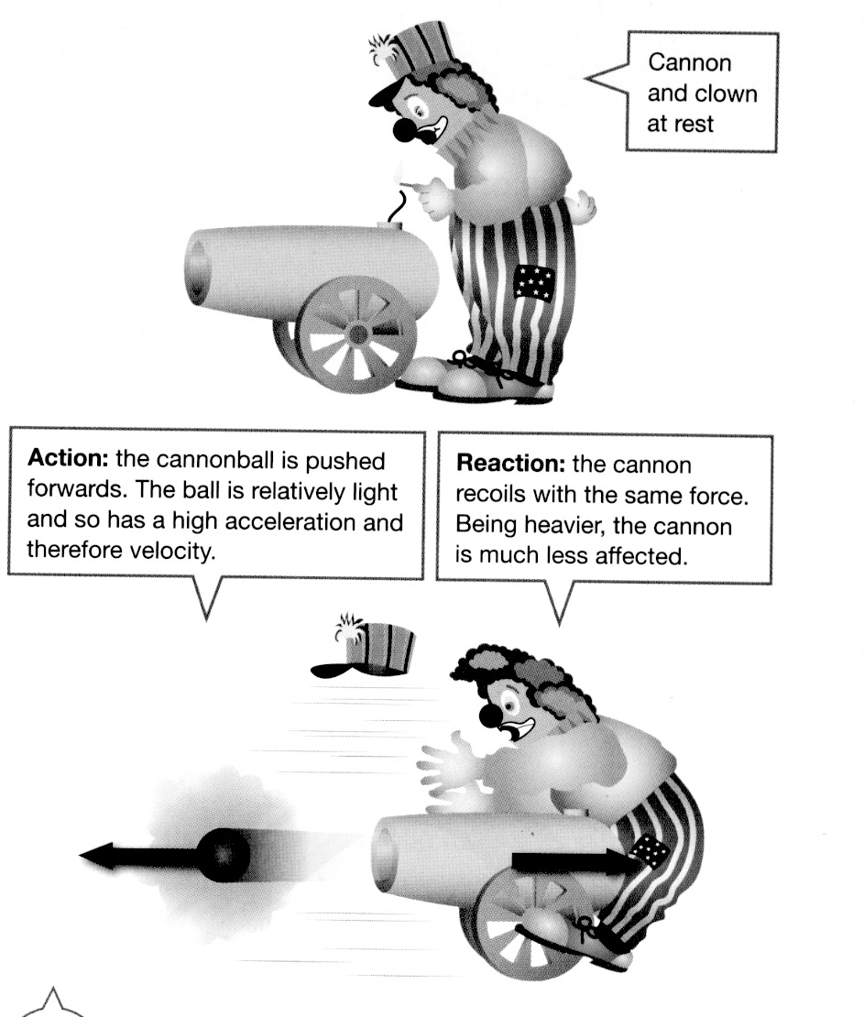
16. Look at the diagram showing a clown and a cannon at
a circus. Analyse it and explain why the cannon hits
the clown, using Newton's Laws in your explanation.
(2 marks)

17. At the 2016 Singapore Grand Prix, Daniel Ricciardo accelerates quickly from the start and reaches 285 km/h (79.2 m/s) after 4.7 s. He is nearly at the first corner.

(a) Calculate the average acceleration of the car. (3 marks)

(b) Ricciardo is still travelling at 285 km/h (79.2 m/s) when he has to brake strongly to reduce the speed of the car to 110 km/h (30.6 m/s) to make it around the first corner. Given that the mass of the car is 780 kg and it takes 1.2 s to slow the car, calculate:

(i) the deceleration of the car. (3 marks)

(ii) the average force exerted by the brakes. (3 marks)

(c) At the start of the race, a car was hit and sent sideways into the rubber tyre wall, which acts as a safety device to protect the drivers.

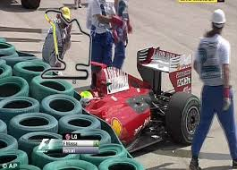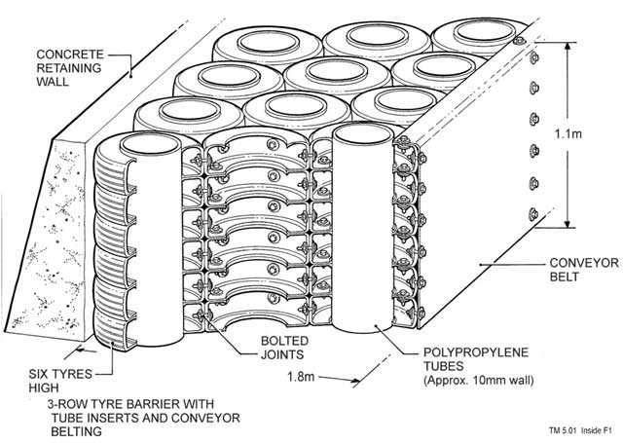

(i) Explain the Physics principle behind how the tyre wall acts as a safety barrier.
(2 marks)

(ii) Tyre walls are around every corner on the track. When a car loses grip and starts to slide, it goes off the track in a straight line, even if it is skidding sideways.
Using one of Newton's laws, explain why this happens. (2 marks)

(d) During the race, Ricciardo set a new race lap record of 110.041 s (1 min 50.041 s). Given the track is 5065 m long, calculate his average speed for the lap. (3 marks)

SECTION 3 COMPREHENSION (17 marks)

Read the article and then answer the questions that follow. Write your answers in the spaces provided.

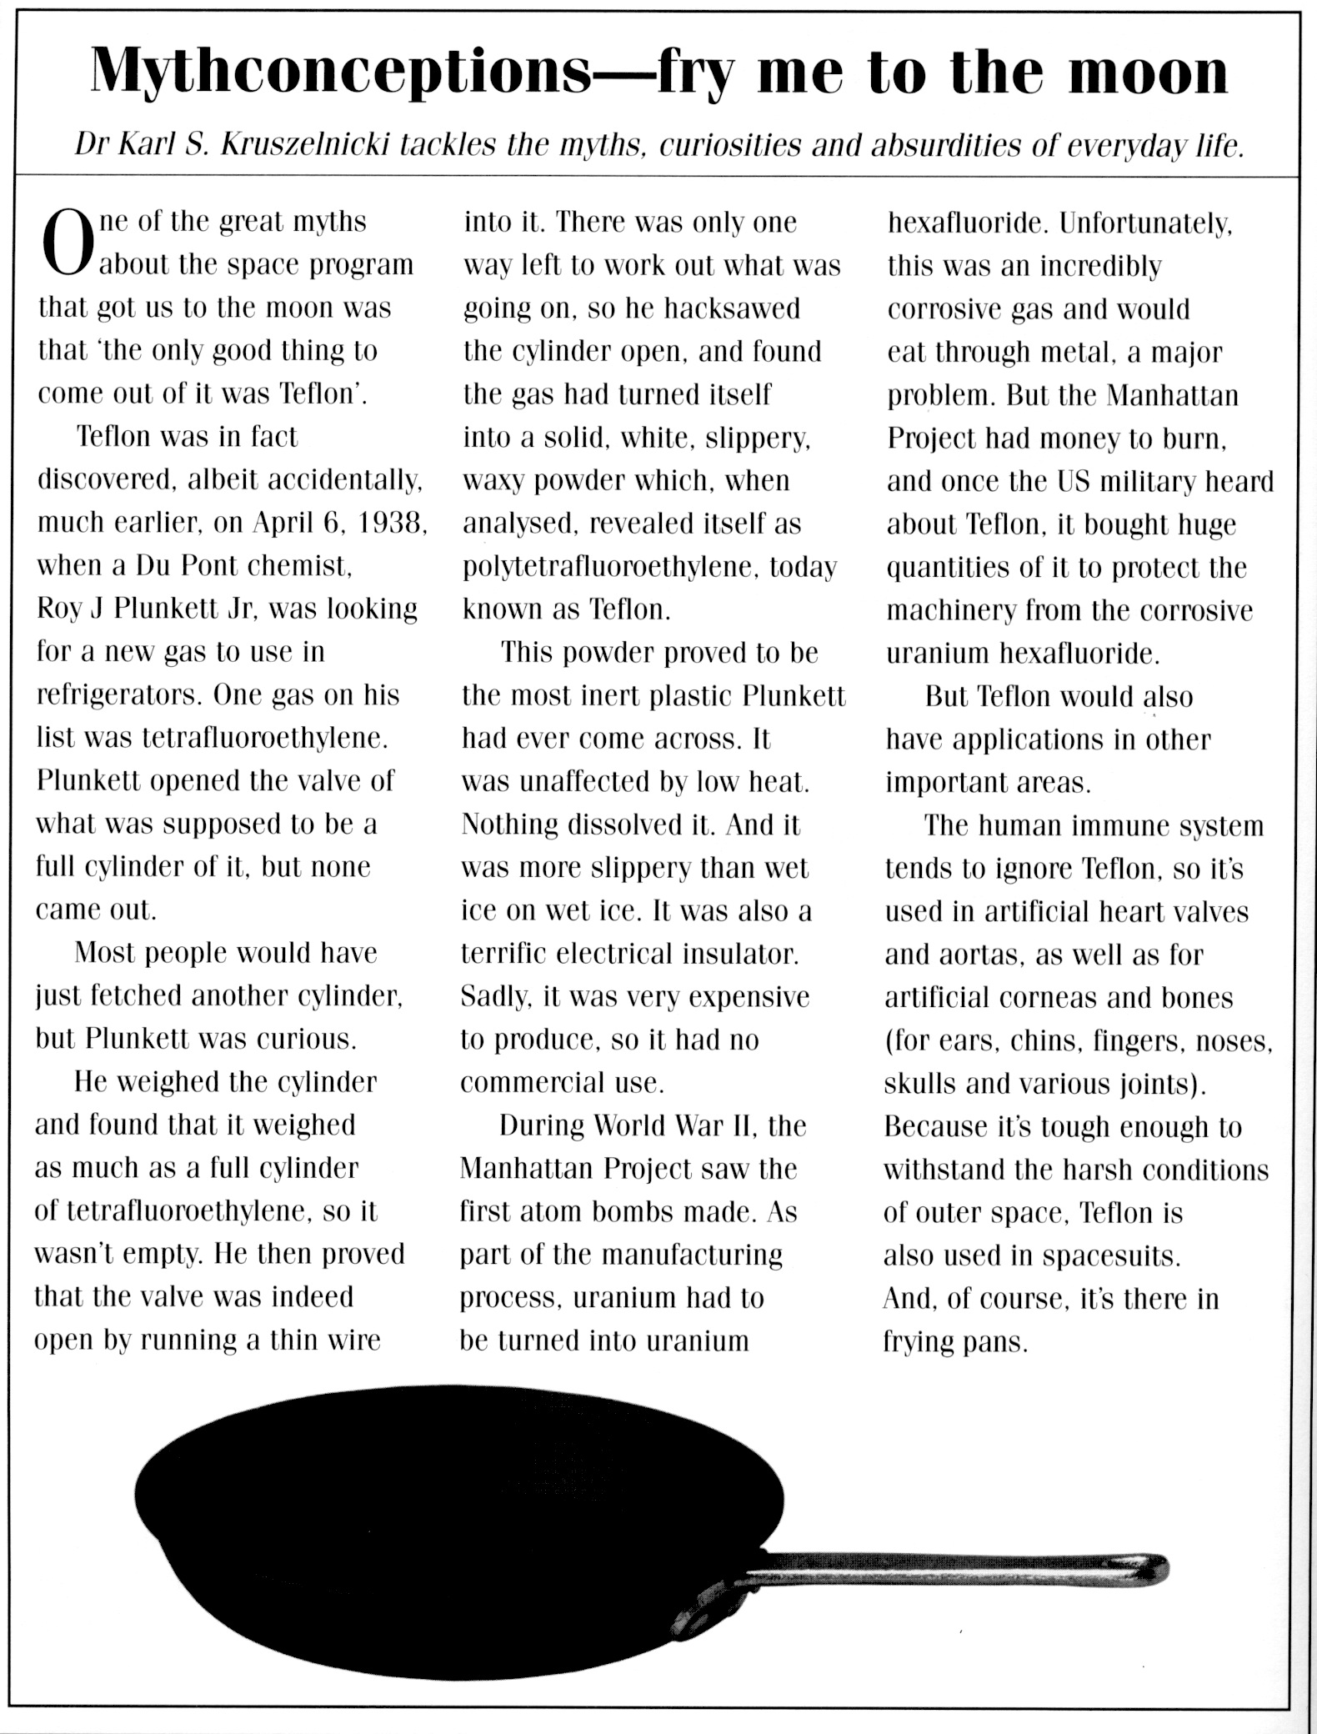
1. When was Teflon discovered and by whom?

(2 marks)

2. What is the correct chemical name of Teflon?

(1 mark)
3. Describe what Teflon looks like.

(2 marks)

4. What properties make Teflon an extremely useful material?

(2 marks)

5. Teflon is said to be inert - what does this mean?

(1 mark)

6. What research was the inventor doing when he discovered Teflon?

(1 mark)

7. What stopped Teflon from being commercially produced in the early days?

(1 mark)

8. Is Teflon a metal or a plastic? Give one piece of evidence.

(1 mark)
9. Complete the following table about the uses of Teflon.

LOCATION | USE | PROPERTY RELATED TO USES
Body
Space
Kitchen

(6 marks)

END OF EXAMINATION

THIS PAGE HAS BEEN DELIBERATELY LEFT BLANK.
THIS PAGE HAS BEEN DELIBERATELY LEFT BLANK.
THIS PAGE HAS BEEN DELIBERATELY LEFT BLANK.

